Oscar Souchaud
11/06/2024

Executive Summary
The Workspace feature allows users to create workspaces, so that users can group projects and share them with specific teams. This feature will enable users to seamlessly switch between different workspaces, ensuring that they can easily access and manage the relevant projects based on their current context or team collaboration needs. It also allows them to manage their sources under distinct workspaces, including personal.

Feature Name | Workspaces
Product Area | Project Organisation
User Persona/ Story | As a <user> I want to <create and join workspaces> to easily differentiate between different types of projects and teams.
Description | Overview  Create, share, and switch between distinct project groups (workspaces) for specific teams.  Key Features  - Create and delete workspaces  - Invite others via email and manage member roles  - Rename existing workspaces  - Interface for switching between workspaces (dropdown or side panel)  - Indication of the current active workspace  - Extension to select the active workspace and access workspace projects
User Problem | - Differentiating between personal and shared projects (e.g. for organizations doing B2B)  - Users that work in organisations that also require personal workspaces.
Value Proposition | - Distinct workspaces for personal and team projects  - Easily swap between the two  - Improved collaboration and communication of sources and information within teams and shared personal projects
Objectives | - User Satisfaction & Retention: Addresses “project” management pain points.  - Increased Productivity: Reduces clutter, improves efficiency  - Product Evolution: Future development and types of features for business versus personal use.
Assumptions | - Users prefer having distinct environments for personal and shared projects.  - There is a demand for improved team collaboration tools within business environments.
Out of Scope | - Third-party API integrations e.g. Slack,  - Automation features  - Project types
MVP | - Create and delete workspaces  - Invite others via email and manage member roles  - Rename existing workspaces  - Interface for switching between workspaces (dropdown or side panel)  - Indication of the current active workspace  - Extension to select the active workspace and access workspace projects  - (TBD)  - Unassigned Sources can be accessed from all workspaces, we can partition it according to which workspaces it was added to, but the idea is to allow all unassigned to move easily between workspaces
KPIs | - Number of active personal and business workspaces created  - User engagement metrics (e.g. nb of projects created, nb of sources saved, frequency of sources and projects been added and created).
Requirements | - Scalable backend to support team collaboration features
Competitor /Market Research | Slack:  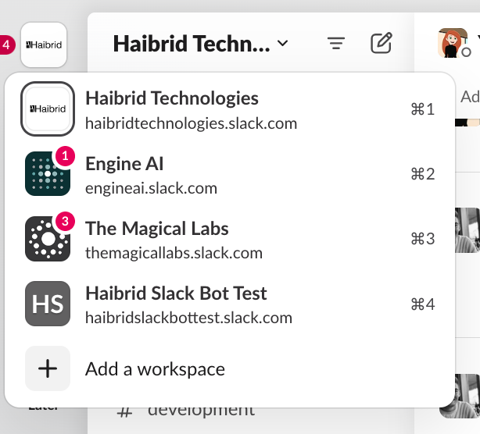  Notion:  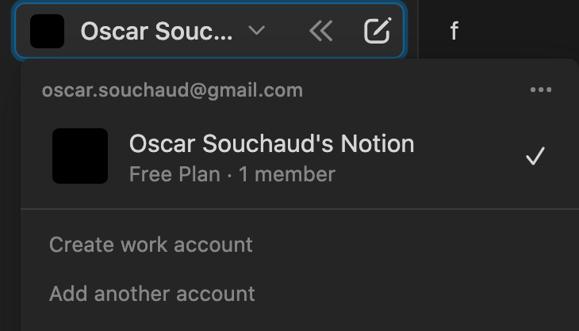
High-level Mock Ups | 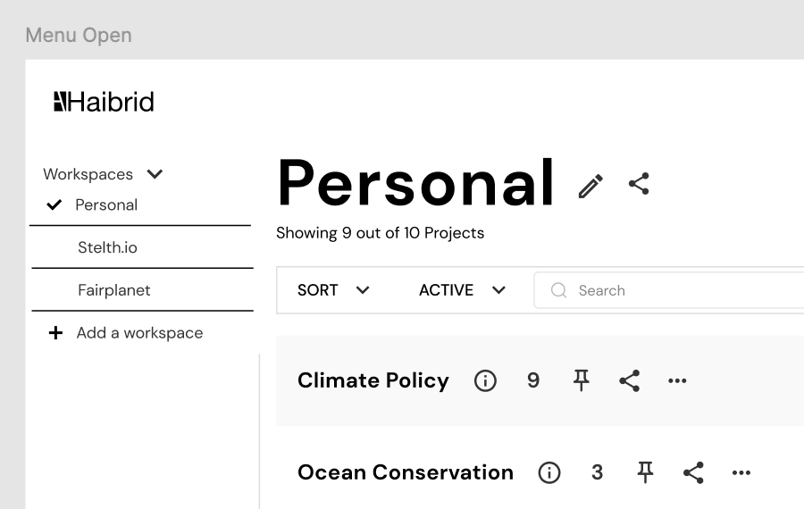  - All projects changed to name of the workspace, name can be edited through a modal and edit who the workspace is shared to.  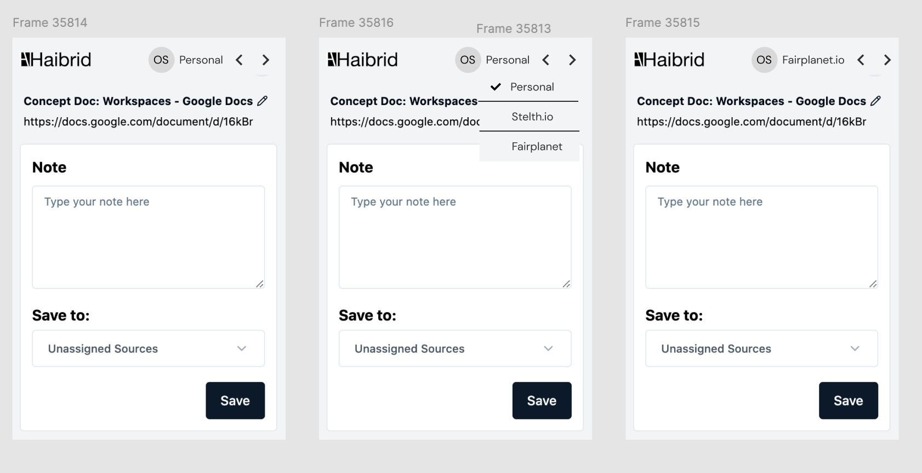  - Would be great to get a “Arc” style interaction here, it works well, e.g. their change of toolbar colour easily indicates to the user which window their are in  